**LAB MANUAL**

**Chapter 6 | ARTIFICIAL INTELLEGENCE**

**Lab – 26**



**Data Modeling in Power BI and DAX for Calculated Columns and Measures**

**Data Modeling in Power BI and DAX for Calculated Columns and Measures**

**Objective:**

To import data, visit the ‘Home‘ menu from the top, then click on ‘Get Data’ and select the method you want to use. It will take some time to process and show results on your screen. If you feel that your data is properly loaded, click on the ‘Load’ button. Else, click ‘Transform Data’ to make some changes.

Here we will import from an excel sheet that contains tables. These tables represent the relationship with data inserted on rows & column. Power BI automatically recognize the data & its relation in a table on a single import.

**Equipment Required:**

The following list provides the minimum requirements to run Power BI Desktop:

**Important**

* Power BI Desktop is no longer supported on Windows 7.
* Windows 8.1 or Windows Server 2012 R2 or later.
* .NET 4.7.2 or later.
* Microsoft Edge browser (Internet Explorer is no longer supported)
* Memory (RAM): At least 2 GB available, 4 GB or more recommended.
* Display: At least 1440x900 or 1600x900 (16:9) required. Lower resolutions such as 1024x768 or 1280x800 aren't supported because some controls (such as closing the startup screens) display beyond those resolutions.
* Windows display settings: If you set your display to change the size of text, apps, and other items to more than 100%, you won't see some dialogs that you must interact with to continue using Power BI Desktop. If you encounter this issue, check your display settings in Windows by going to Settings > System > Display, and use the slider to return display settings to 100%.
* CPU: 1 gigahertz (GHz) 64-bit (x64) processor or better recommended.
* WebView2: If WebView2 wasn't automatically installed with Power BI Desktop or if it was uninstalled, [download and run the installer for WebView2](https://go.microsoft.com/fwlink/p/?LinkId=2124703).

**Note**

We recommend using a client version of Windows, such as Windows 10, instead of Windows Server. Power BI Desktop doesn't support Internet Explorer Enhanced Security Configuration because it will stop Power BI Desktop from signing in to the Power BI service.

**Prerequisites:**

1. Internet skill to access the Power BI site
2. Computer OS skill to install the software

**Problem Statement:**

We will be using simple electronics shop sale records as our data to create Data Models. This data includes the Shop Sales with parameters as customer, country, product, cost, month and year.

**Solution:**

To automatically detect all the possible relations between different sets of data. Sometimes we need to create a relation between the data manually. Visit the ‘Models’ tab from the left side, as highlighted in the above image. Here you will see some automated relation created by Power BI. All the lines visible here in the ‘Models’ tab depicts the cardinality and direction of the relation from one table to another. You can create & modify this default relationship created by Power BI using the Manage Relationship tool

**Create And Manage Relationship**

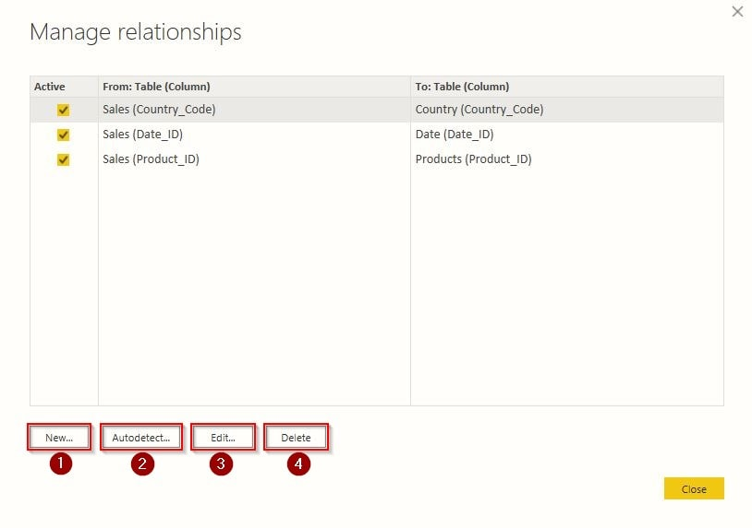

After clicking on ‘Manage Relationship,‘ a similar screen will appear, as shown in the above image. You can see all the active relations here from one table to another. All the things you can do with these relations are explained below:

1. **New**– This option will help you create a new relationship between tables.
2. **Autodetect** – Using this option, Power BI automatically detects the relationship between data present in tables.
3. **Edit** – This option will help you to edit your data relationship.
4. **Delete** – It deletes the selected relationship between the tables.

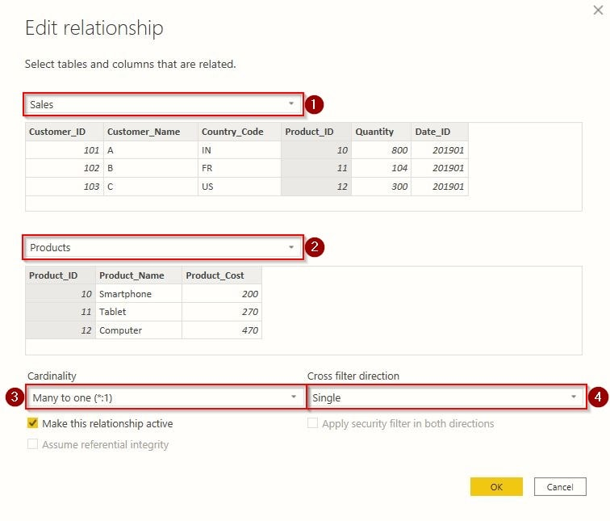

Now after clicking on ‘New‘ or ‘Edit‘, a similar screen will appear in front of you, as shown above. Here we will explain to you the purpose of all the options one by one.

1. The first drop-down menu will allow you to select your table from which you want to create a relation.
2. The selection in the second drop-down menu will create a relation from the first table to the second.
3. You will select the Cardinality relation here, but you can not force Power BI to select a specific cardinality that doesn’t exist.
4. Here you can select the direction of the relationship as ‘Single’ or from ‘Both’.

**Calculate And Measure Data**

If you are familiar with Excel, you may have worked on the DAX (Data Analysis Expression) formula. If not, then no worries. I will explain in short and simple words. Like programming, DAX is a set of instructions used to calculate data from the tables. These expressions include commands for Addition, Multiplication, Average, Percentage and others with various filters.

For Example :

1. Table 1 = DISTINCT(Table 2[Column_1]), this expression will fill all the unique values in Table 1 from Column_1 present in Table 2.
2. Column1 = RIGHT(Table1[Column_Name],3), this expression will get last 3 characters from Column_Name to fill in Column1.

Let’s create some calculations with our shop data present in Power BI. Visit the ‘Data‘ tab from the left menu as highlighted in the image below. Here you will see some tools to calculate your data. We will be using these on Power BI.

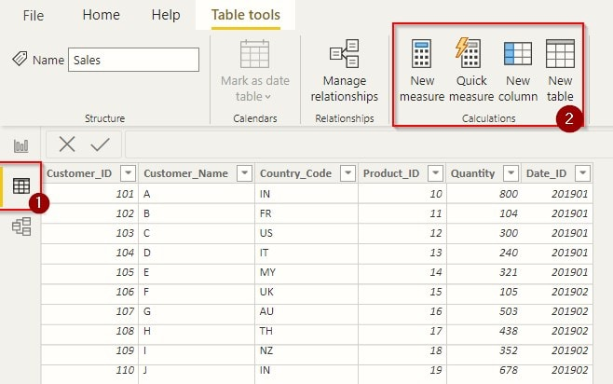

**Create Table**

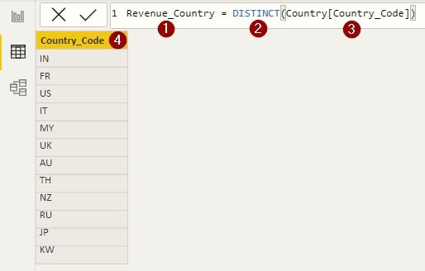

After clicking on ‘New Table‘, we need to enter the DAX expression shown in the above image.

1. The first part of the expression defines the name of the table.
2. The second is the filter; the ‘DISTINCT’ function will select only the unique values from the column.
3. We need to pass the parameters inside the ‘DISTINCT’ function, and these parameters are the location from which we will extract our data. So we have passed the table and column name where our country codes are present. When your expression is complete, click ‘Enter’.
4. After applying the expression, we will get our new column with the default name and results. To rename a column, you can double click on it.

**Create Column**

Click on ‘New Column‘ from the top menu to create a calculated column.

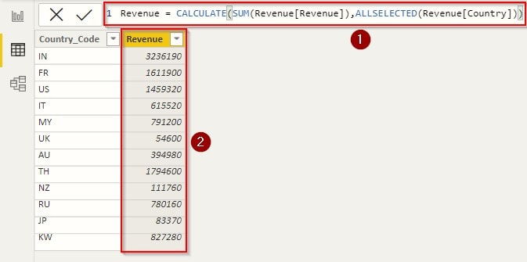

1. The DAX expression will calculate all the revenue from the table ‘Revenue‘ with filter as ‘Country‘. Without this expression, we might have spent hours calculating the individual revenue generated from the country.
2. This is the result we get from the expression.

Although Power BI suggests you write an expression, it might be difficult to remember all the expressions. If this is the case, you can use the Quick Measure tool. You will only need to fill in the parameters and function for calculation. This tool will then generate the expression automatically, depending on your selection. These measurement tools are also helpful when you want quick calculations for your reports.